GRADLE

INSTALLATION MANUAL

BY: GROUP 2

ICS 312L |PROGRAMMING APPLICATIONS | 4:00-5:30 WS

Windows installation for Gradle

1. Unpack Gradle

2. Create a new folder in C: named Gradle

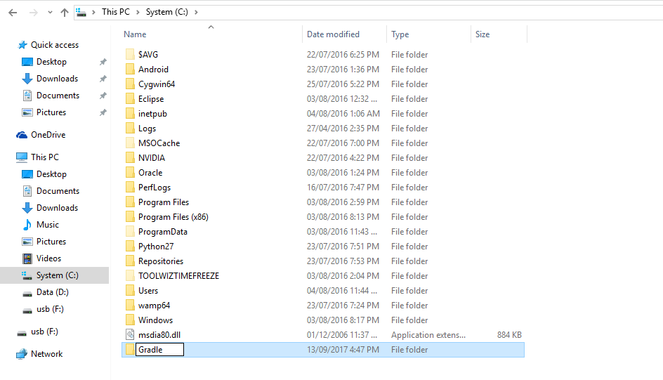 "C:\Gradle"

3. Place gradle-4.1 to Gradle

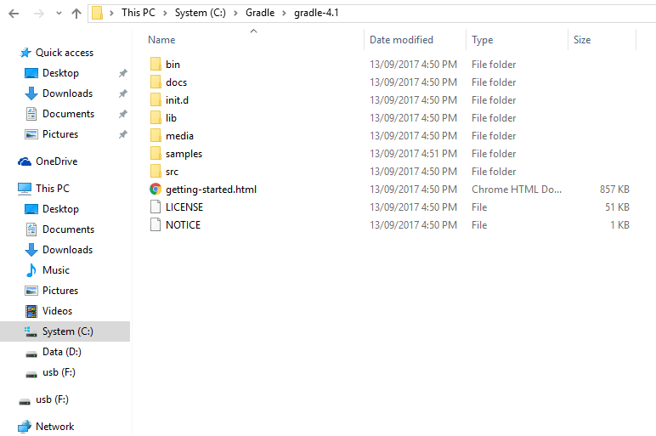



­­­­­

4. Right-click 'This PC', then 'Properties->Advanced System Settings->

Environmental Variables

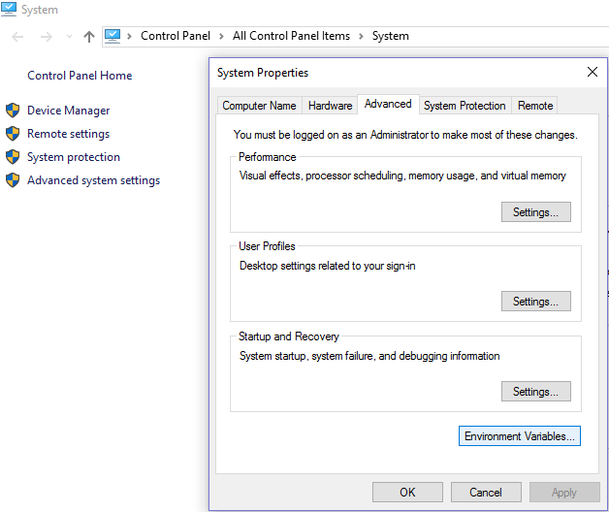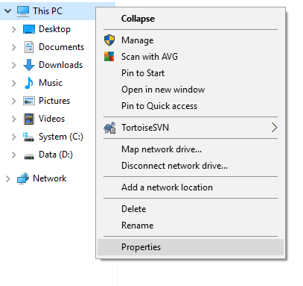

5. Under 'System Variables' select 'Path' , then click 'Edit' , add an entry for

"C:\Gradle\gradle-4.1\bin". Click OK to save.

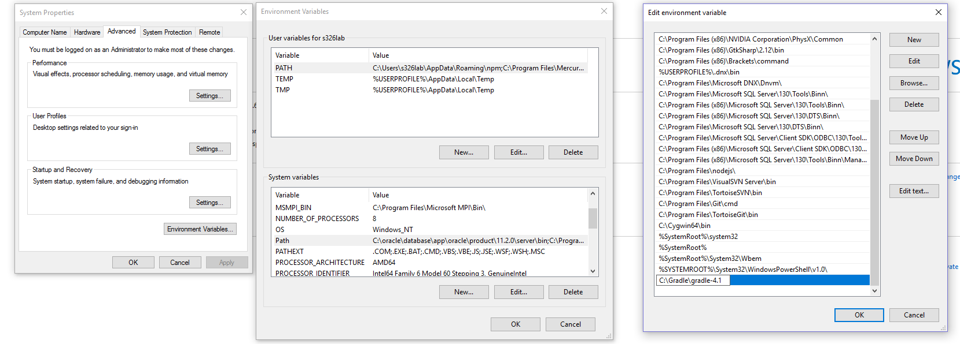

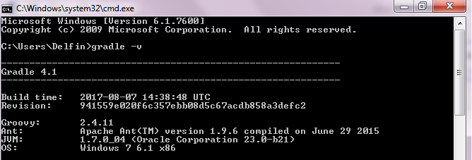6. To verify installation, run command line then input "gradle -v"

MAC Installation for Gradle

1. Unzip the gradle into the file of your choosing

2. Configure your 'PATH'environment variable to inlcude the 'bin' directory of

the unzipped distribution, e.g:

$ export PATH-$PATH:/opt/gradle/gradle-4.1/bin

3. To verify, open command line the input'gradle -v'

SETTING UP GRADLE

1. Create a base folder

Example: C:\GradleEX

2. Create a source folder where you can put your java file

Example: C:\GradleEX\src\main\java

3. Place the java file in the java folder located in C:\GradleEX\src\main\java

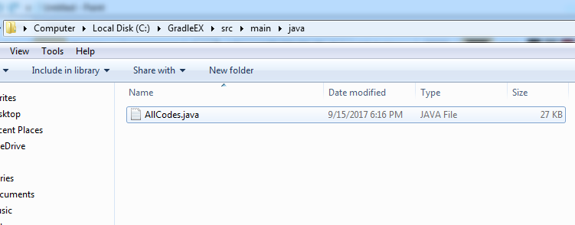



4. Create a test folder in the source folder where you can put your files for unit testing

Example: C:\GradleEX\src\test\java

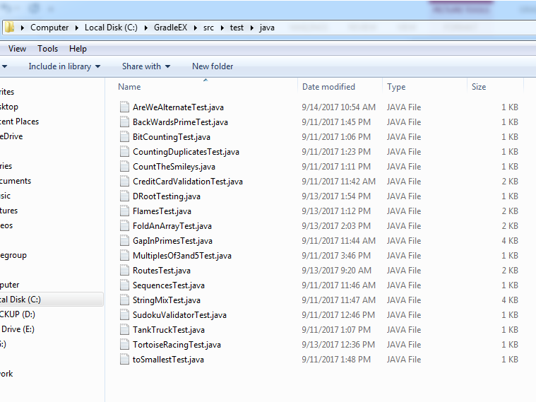5. Put the unit test files where the test folder is located



6. Open the command prompt and change the directory where the base folder is located

Example: cd C:\GradleEx

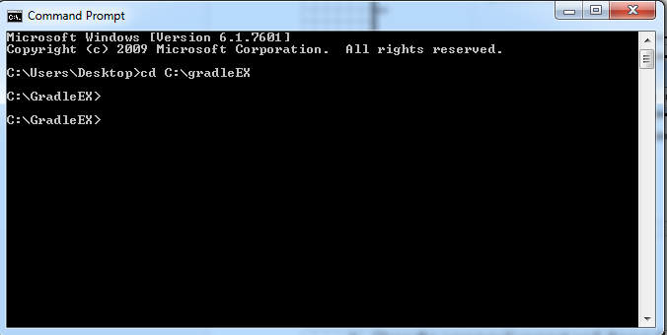

7. Type “gradle init” in the command prompt to initialize the gradle.

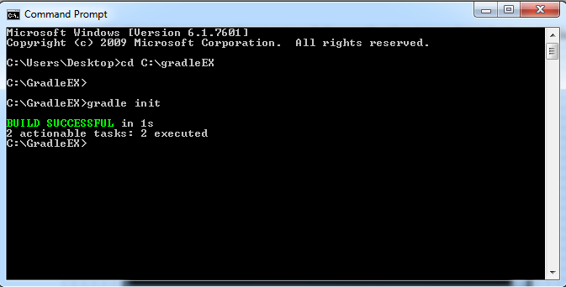

8. Go back to the base folder and open the “build.gradle”with any text editors. This is where you’re going to place the scripts on compiling, creating javadoc, creating jar file, unit testing, and coverage test. (You don’t have to write the script anymore for we already made it.)

